**Software Development Coursework**

**Iñaki McKearney**

**Using C# to Develop a Maths Quiz**

**Candidate Number - 9135**

**Centre Number - 71650**

Contents

1. Title
2. Contents
3. Background Information
   1. Design

7. MSCW Requirements

8-12. Screendumps

14. User Requirements

Background Information

My maths teacher approached me to request that I create a program to help his students revise for maths tests. This would allow the students to practise their skills at home, in their free time, in a manner that would be more entertaining for them and therefore enable them to concentrate on their revision by enjoying the activity at the same time. The easy-to-use layout of the quiz will mean that students can get started revising immediately without wasting any time. My teacher also suggested that I use a range of questions with different grades of difficulty to test the students’ core math skills so that the practice they get is applicable to their tests. We concluded that the addition of a digital blackboard to the quiz would be beneficial to the students’ maths abilities as they will be able to work out the answers without the use of a calculator or other electronic devices.

Design

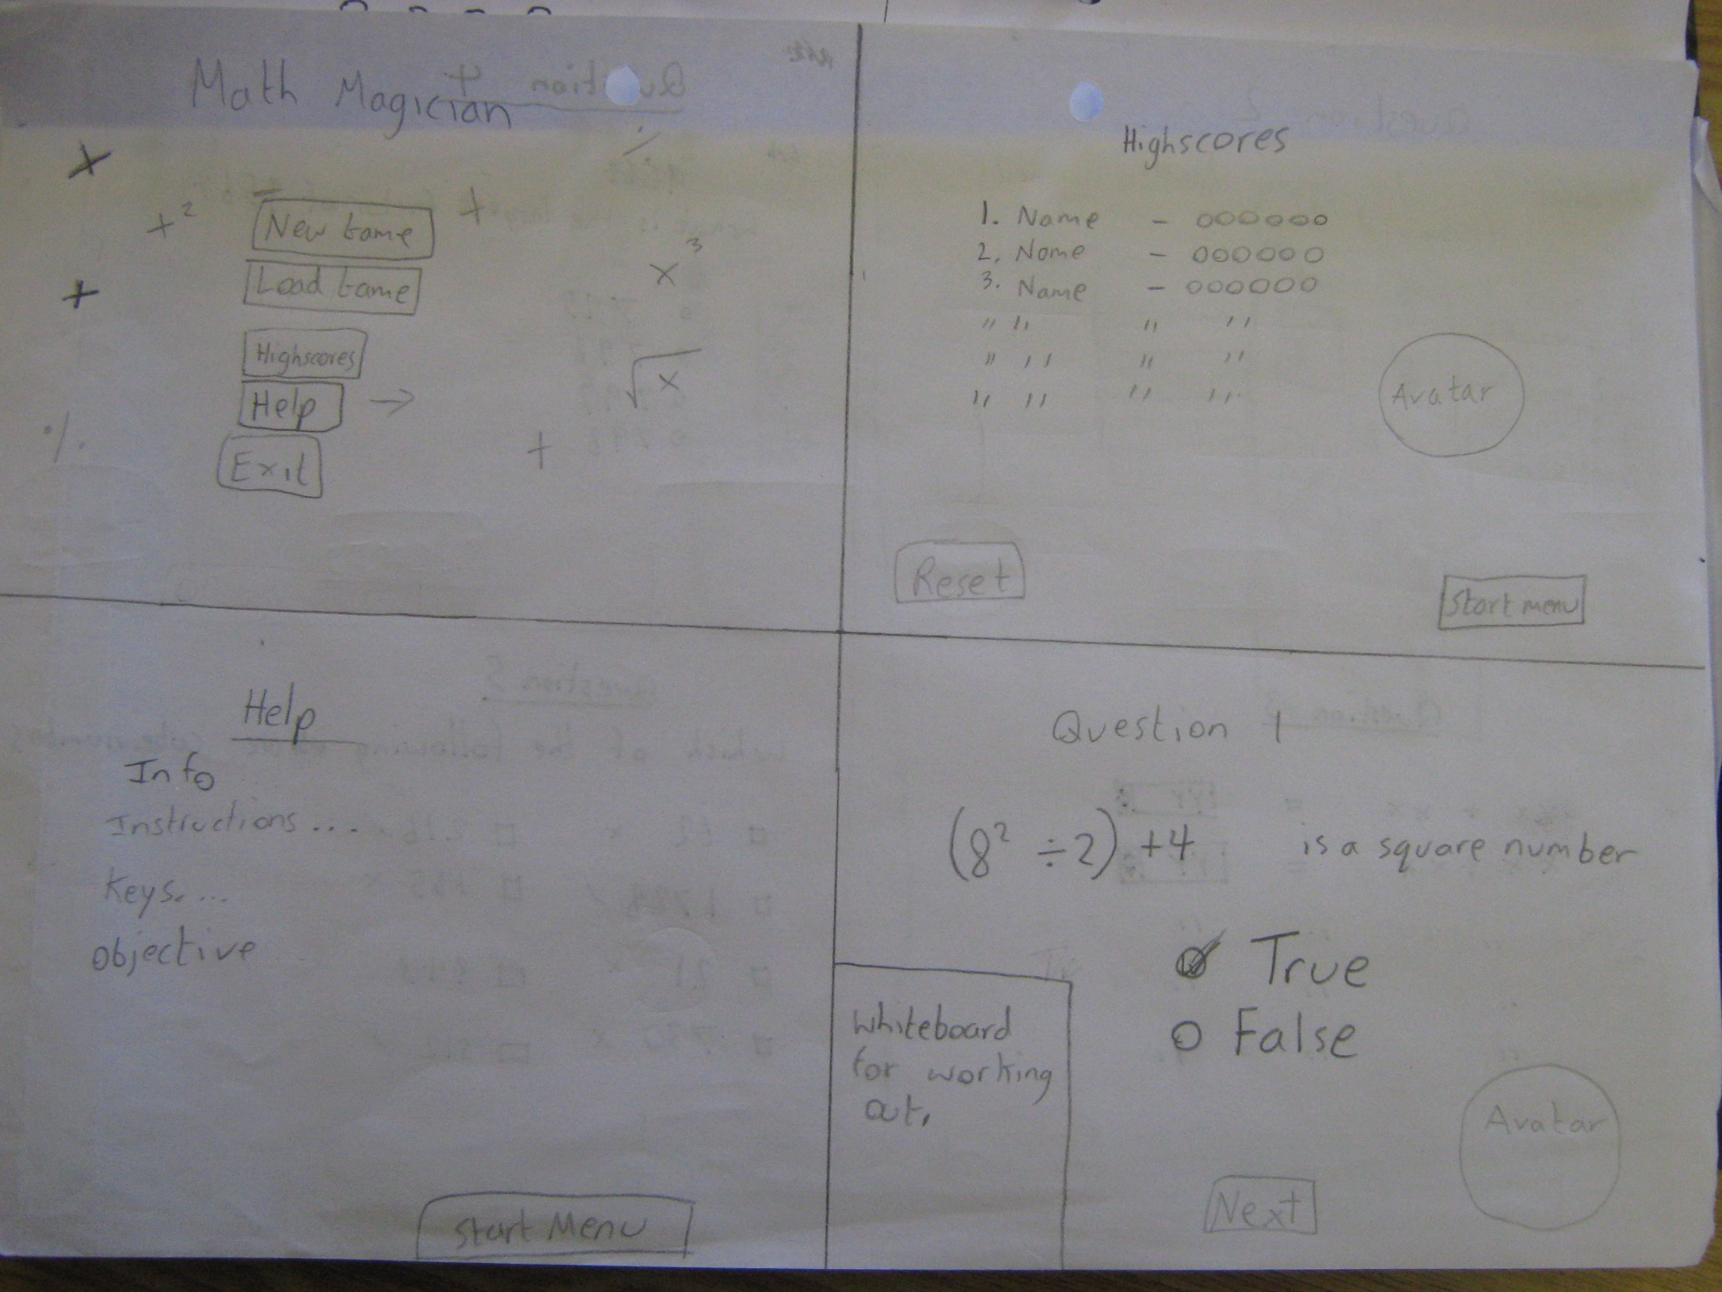

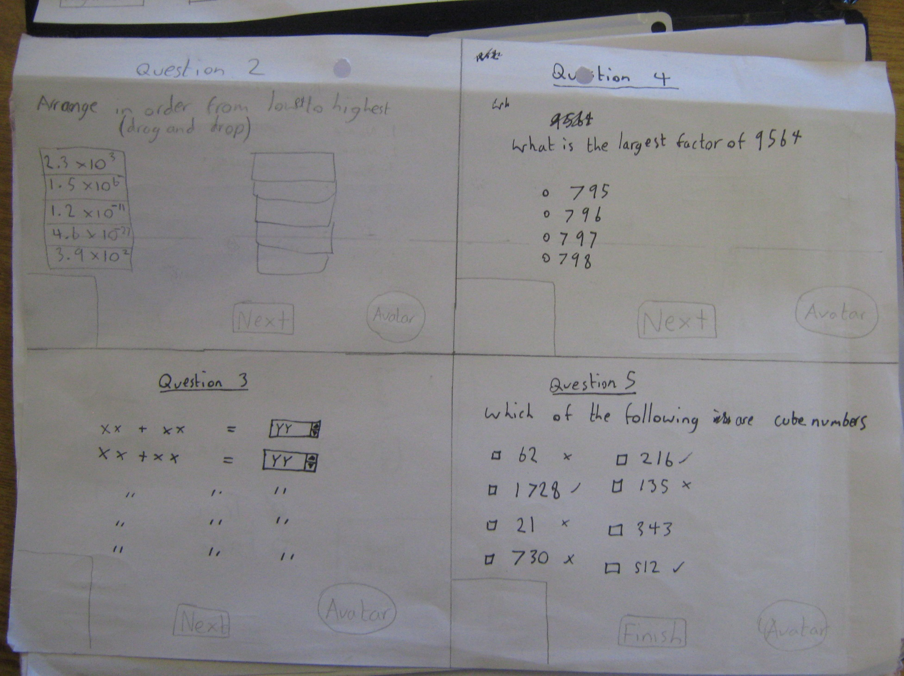

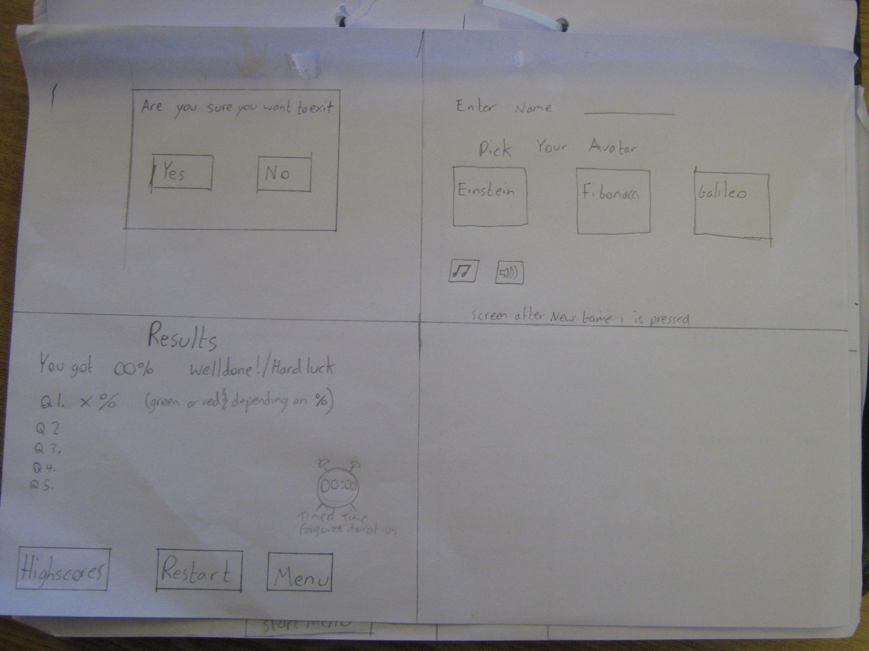

MSCW User Requirements

**Must Have** (Critical for project success):

* Questions
* Answers
* Navigation Buttons
* Feedback/Verification System

**Should Have** (Important for project success):

* Blackboard
* Help System
* Score
* Appropriate Graphics

**Could Have** (Nice to have):

* High Scores
* Presence check
* Numeric Validation
* Player Avatar

**Won’t Have** (Least-Critical, no priority):

* Timer
* Sound
* Colour variety for blackboard pen
* Save files

Screendumps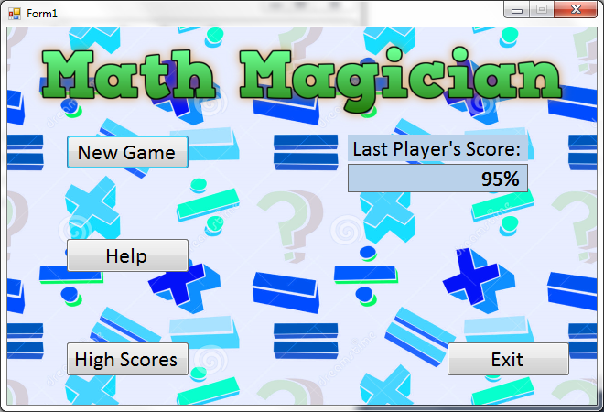

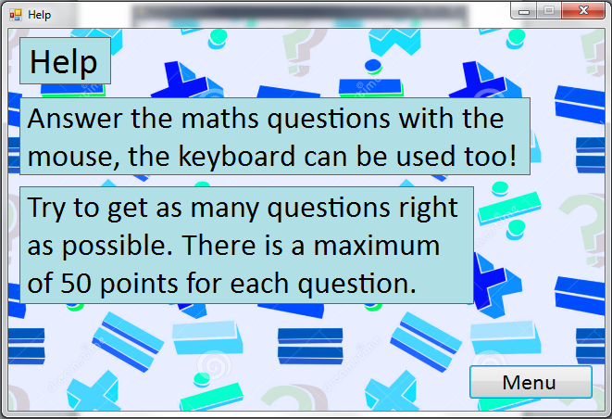

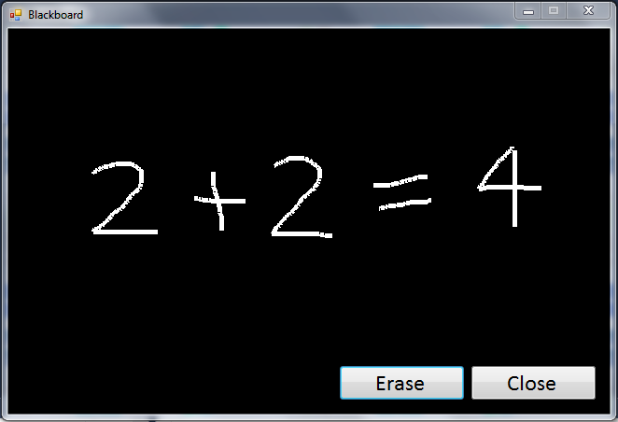

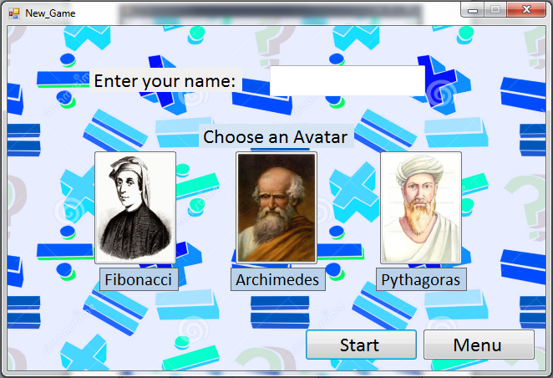

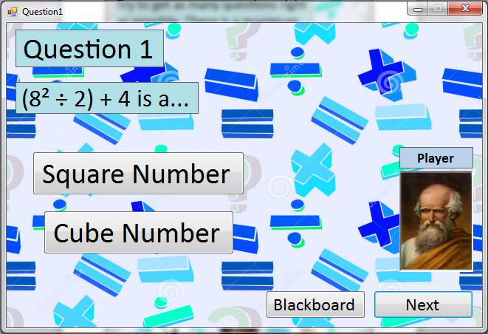

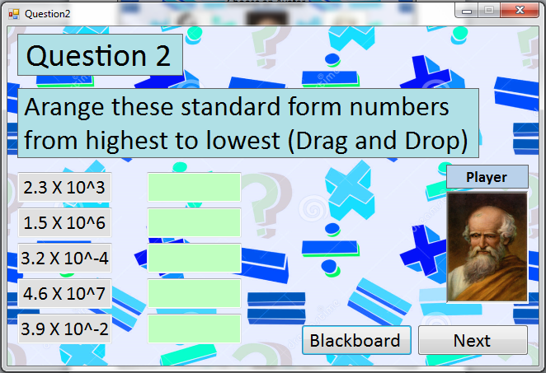

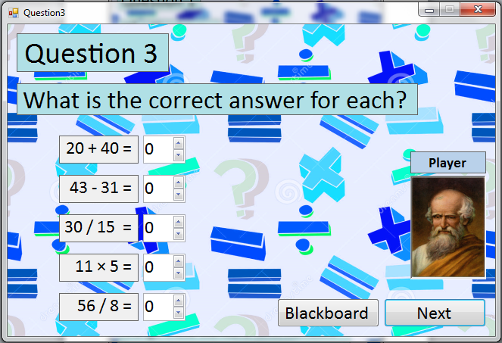

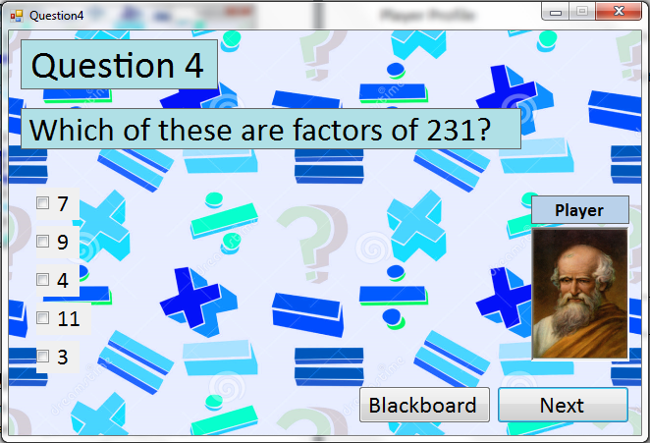

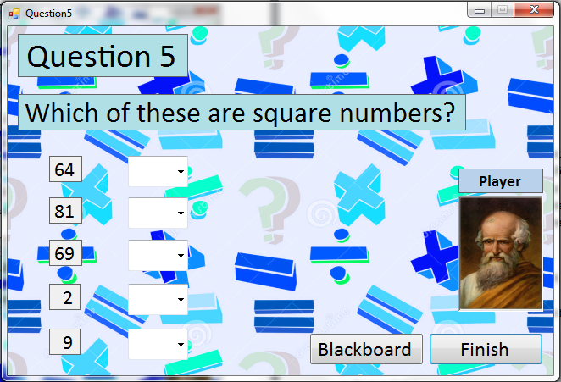

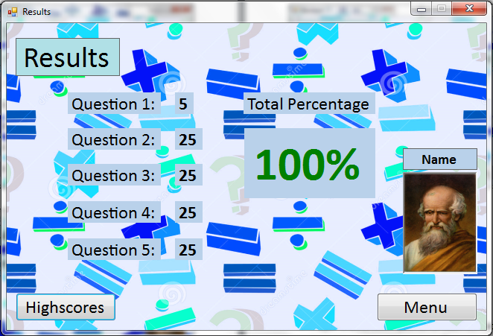

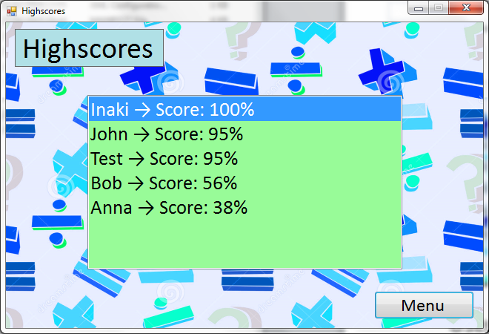

User Requirements

Scoring System

* Player is awarded 5 points for each correct answer
* Some longer questions may offer up to 25 points
* Player score will be displayed as a percentage so that the user can get a bet idea of their performane.
* Players will be given an option to save their high score

Player Profile

* Player has the option of choosing from three avatars: Archimedes, Fibonacci and Pythagoras.
* The player will be able to use their name to save their high score.

Types of Question

* True or False
* Drag and Drop
* Numeric Up Down
* Multiple Choice
* Multiple Answer

Developer Signature:

Signature: